Sample DB connector to pull accounts and Entitlements

Introduction:  
Saviynt EIC offers OOB capability to integrate DB applications with Saviynt with the help of database connectors. Saviynt Provides OOB templates that can be configured accordingly.  
  
  
How it works:  
  
Saviynt offers a connector module which can be configured to make a connection with the application.  
  
  
Prerequisites:   
  
Network connectivity should be established before we can begin operations like recon and provisioning. The network needs to be whitelisted, and firewall should allow the network to flow from Saviynt to EIC and vice versa.  
  
Integration Steps:  
  
Create an DB connection. Let’s look at the integration steps .

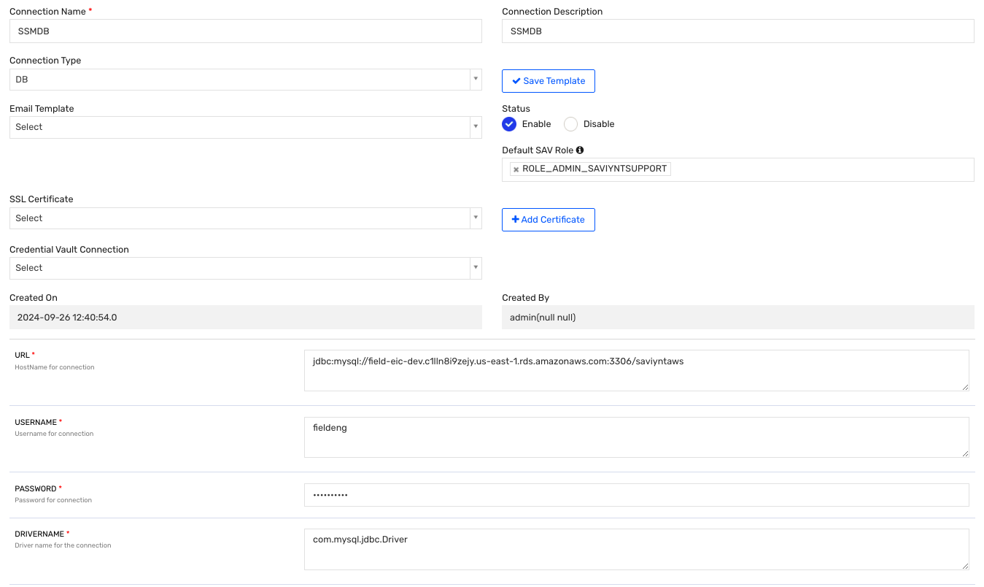

1)Provide a Connection Name and Description.  
2) Select the Connection Type as DB, it will load the template below according to AD connection.  
3) Give the URL: This is the hostname of the DB to which we are trying to connect. Provide schema also  
4) Give the username and password.  
5) Provide the drivername accordingly to the database to which we are connecting. com.mysql.jdbc.Driver in case of mysql

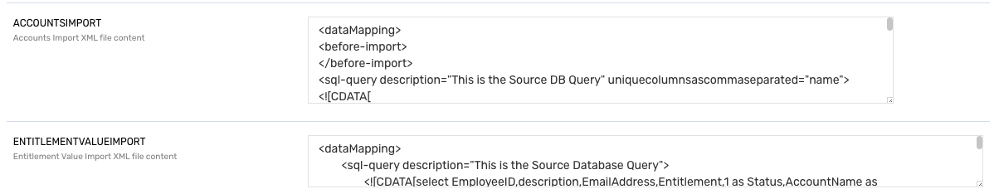

6) Provide The account Import: this is an xml file which will fetch the data from the database and map it into Saviynt fields.  
  
example:  
<dataMapping> <before-import> </before-import> <sql-query description="This is the Source DB Query" uniquecolumnsascommaseparated="name"> <![CDATA[ select EmployeeID,EmailAddress,Entitlement,cast(Status as varchar) as Status,AccountName as ACCNAME,EndpointName,EndpointName as SecuritySystem,case when endpointname='Treasury Management System' then 'Groups' else 'Role' END as EntitlementType from DISCONNECTED_USERDATA where endpointkey = 10 ]]> </sql-query> <mapper description="This is the mapping field for Saviynt Field name" accountnotinfileaction="Suspend" deleteaccountentitlement="true" ifusernotexists="noaction" systems="'Treasury Management System'"> <mapfield saviyntproperty="securitysystems.systemname" sourceproperty="SecuritySystem" type="character"></mapfield> <mapfield saviyntproperty="endpoints.endpointname" sourceproperty="EndpointName" type="character"></mapfield> <mapfield saviyntproperty="accounts.name" sourceproperty="ACCNAME" type="character"></mapfield> <mapfield saviyntproperty="accounts.customproperty1" sourceproperty="EmployeeID" type="character"></mapfield> <mapfield saviyntproperty="accounts.customproperty2" sourceproperty="EmailAddress" type="character"></mapfield> <mapfield saviyntproperty="entitlementtypes.entitlementname" sourceproperty="EntitlementType" type="character"></mapfield> <mapfield saviyntproperty="entitlementvalues.entitlementvalue" sourceproperty="Entitlement" type="character"></mapfield> <mapfield saviyntproperty="accounts.status" sourceproperty="Status" type="character"></mapfield> </mapper> <after-import description="EMAIL,BATCH,SQL"> </after-import> </dataMapping>

* **Data Mapping Structure**:

<dataMapping> serves as the main container for the import configuration.

* **Before Import**:

<before-import> is an empty placeholder, likely reserved for any preparatory steps or actions before the main import occurs.

* **SQL Query**:

<sql-query> defines the query that retrieves data from the source database.

* **Attributes**:
  + description: Specifies a description of the query, labeled as "This is the Source DB Query."
  + uniquecolumnsascommaseparated: Lists the columns (name) that uniquely identify each record.
* **Query Body**:
  + The query uses SELECT to retrieve data fields like EmployeeID, EmailAddress, Entitlement, Status, and others.
  + It includes a CASE statement for setting the EntitlementType based on the endpointname value.
  + The WHERE clause excludes specific values from the results, such as 'Sudoer Review for AIX'.
* **Mapper**:

<mapper> handles field mapping between the source database and Saviynt.

* **Attributes**:
  + description: Description of the mapping, specified as "This is the mapping field for Saviynt Field name."
  + accountnotinfileaction: Indicates that accounts not found in the source data should be Suspended.
  + deleteaccountentitlement: true means that any entitlement associated with deleted accounts should also be deleted.
  + ifusernotexists: Specifies the action for users not found in the source, set to noaction.
  + systems: A list of endpoint systems associated with this mapping.
* **Map Field Elements**:
* Each <mapfield> element maps a source field to a Saviynt field.
* **Attributes**:
  + saviyntproperty: The target Saviynt property where data will be stored.
  + sourceproperty: The source database field to be mapped.
  + type: The data type for the mapping, here primarily character.
* **Mappings**:
* securitysystems.systemname maps to SecuritySystem.
* endpoints.endpointname maps to EndpointName.
* accounts.name maps to ACCNAME.
* accounts.customproperty1 and accounts.customproperty2 store EmployeeID and EmailAddress.
* entitlementtypes.entitlementname maps to EntitlementType.
* entitlementvalues.entitlementvalue maps to Entitlement.
* accounts.status stores Status.
* **After Import**:
* <after-import> specifies actions or processes (like EMAIL, BATCH, or SQL) that should be triggered post-import.

7) Provide the ENT Import: This is the xml which will help to import the entitlement and metadata associated with the entitlement.  
  
example:  
<dataMapping>

<sql-query description="This is the Source Database Query">

<![CDATA[select EmployeeID,description,EmailAddress,Entitlement,1 as Status,AccountName as ACCNAME,EndpointName,EndpointName as SecuritySystem,case when endpointname='Treasury Management System' then 'Groups' else 'Role' END as EntitlementType from DISCONNECTED_USERDATA where endpointname not in ('Sudoer Review for AIX')]]>

</sql-query>

<mapper description="This is the mapping field for Saviynt Field name" deleteentitlementowner="false" entnotpresentaction="inactive" createentitlementtype="true" systems="'Treasury Management System'">

<mapfield saviyntproperty="securitysystems.systemname" sourceproperty="SecuritySystem" type="character"></mapfield>

<mapfield saviyntproperty="endpoints.endpointname" sourceproperty="EndpointName" type="character"></mapfield>

<mapfield saviyntproperty="entitlementtypes.entitlementname" sourceproperty="EntitlementType" type="character"></mapfield>

<mapfield saviyntproperty="entitlementvalues.entitlement_value" sourceproperty="Entitlement" type="character"></mapfield>

<mapfield saviyntproperty="entitlementvalues.entitlement_glossary" sourceproperty="description" type="character"></mapfield>

<mapfield saviyntproperty="entitlementvalues.description" sourceproperty="description" type="character"></mapfield>

<mapfield saviyntproperty="entitlementvalues.status" sourceproperty="Status" type="number"></mapfield>

</mapper>

</dataMapping>

<dataMapping>

<sql-query description="This is the Source Database Query">

<![CDATA[select EmployeeID,description,EmailAddress,Entitlement,1 as Status,AccountName as ACCNAME,EndpointName,EndpointName as SecuritySystem,case when endpointname='Treasury Management System' then 'Groups' else 'Role' END as EntitlementType from DISCONNECTED_USERDATA where endpointname not in ('Sudoer Review for AIX')]]>

</sql-query>

<mapper description="This is the mapping field for Saviynt Field name" deleteentitlementowner="false" entnotpresentaction="inactive" createentitlementtype="true" systems="'Treasury Management System'">

<mapfield saviyntproperty="securitysystems.systemname" sourceproperty="SecuritySystem" type="character"></mapfield>

<mapfield saviyntproperty="endpoints.endpointname" sourceproperty="EndpointName" type="character"></mapfield>

<mapfield saviyntproperty="entitlementtypes.entitlementname" sourceproperty="EntitlementType" type="character"></mapfield>

<mapfield saviyntproperty="entitlementvalues.entitlement_value" sourceproperty="Entitlement" type="character"></mapfield>

<mapfield saviyntproperty="entitlementvalues.entitlement_glossary" sourceproperty="description" type="character"></mapfield>

<mapfield saviyntproperty="entitlementvalues.description" sourceproperty="description" type="character"></mapfield>

<mapfield saviyntproperty="entitlementvalues.status" sourceproperty="Status" type="number"></mapfield>

</mapper>

</dataMapping>  
  
  
  
**Troubleshooting:  
The most common errors include syntax error in the query and data mismatch .  
  
Resolution:   
Please run the query from the xml in the target database to validate the resultset.**